**Bài 1: Miss IT**

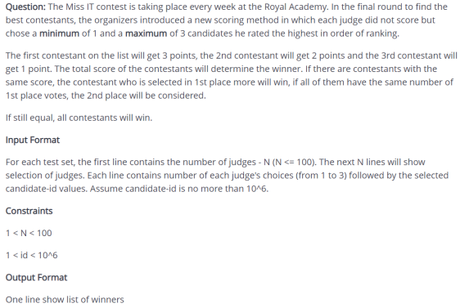

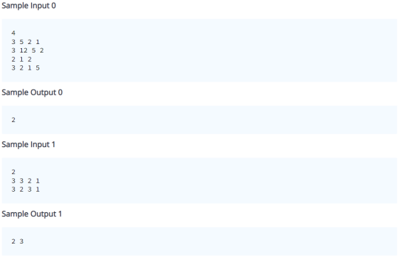

**Bài 2: Happy Number**

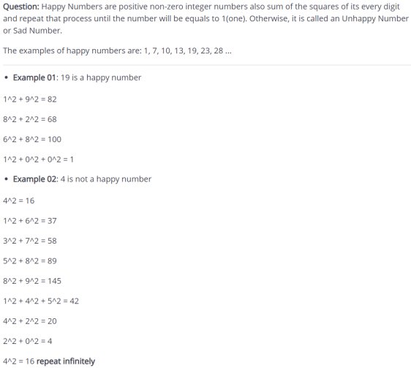

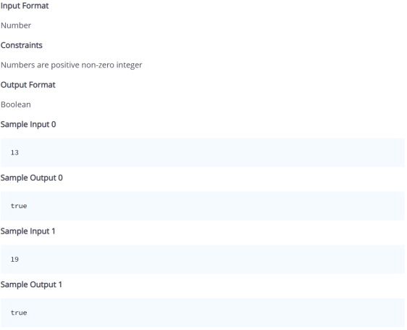**Project name: lesson11-col-tests-hoten**

**Submission branch: lesson11-col-tests**